Open Educational Resources Training Platform (OERTP)
Software Configuration Management Plan
Release 1
Version 1

Raj Bharath Adamaram Seshadri

Contents
1. Introduction 4
1.1 Abbreviations and Definitions 5
1.1.1 Definitions 5
1.1.2 Abbreviations 7
1.2 References 7
2. Management 8
2.1 Organization 8
2.1.1 OERTP Project Organization 8
2.1.2 Software Configuration Management Structure 10
2.2 SCM Roles and Responsibilities 11
2.2.1 Activity Definitions 12
2.2.2 Responsibility Definitions 13
2.2.3 Role Definitions 13
2.3 Applicable Policies, Directives, and Procedures 14
3. Activities 15
3.1 Configuration Identification 15
3.1.1 Identifying CIs 15
3.1.2 Naming CIs 18
3.1.3 Acquiring CIs 20
3.2 Configuration Control 21
3.2.1 Submittal (Requesting Changes) 23
3.2.2 Review (Evaluating Changes) 24
3.2.3 Approval (Approving or Disapproving Changes) 25
3.2.4 Deferring a CR 25
3.2.5 Appealed (Overruling Rejection or Forwarding) 26
3.2.6 Authorization 26
3.2.7 Execution (Implementing changes) 26
3.2.8 Closure (Closing the CR) 27
3.3 Configuration Status Accounting 27
3.3.1 Configuration Data 28
3.3.2 Configuration Reports 28
3.4 Configuration Audits and Reviews 29
3.4.1 Code Review 30
3.4.2 Functional Configuration Audit (FCA) 30
3.4.3 In-Process Audit 31
3.4.4 Physical Configuration Audit 31
3.5 Interface Control 32
4. SCM Schedules 33
5. SCM Resources 34
5.1 Software Resources 34
5.2 Hardware Resources 35
5.3 Human Resources 35
6. SCM Plan Maintenance 37

1. Introduction
This document provides the foundation for designing Drupal based OERTP project configuration management plans (CMPs). This plan conforms to the requirements of IEEE STD 828-1990. All project CMPs derived from this plan will also conform to IEEE STD 828-1990.
1.1 Purpose
This document provides a Configuration Management Plan for OERTP (Open Educational Resources-Open Training Platform) projects which are constructed using the Drupal 7 Content Management System frame-work. It describes the minimal Software Configuration Management (SCM) process which these projects will follow. This Configuration Management Plan explicitly identifies process areas that can be tailored for individual projects and usually provides fully usable suggestions for the most common project environ-ments. A Project Manager can create a CMP which simply refers to particular sections of this plan and write very little original text.
A very important secondary resource for creating project Configuration Management Plan is IEEE Std 828-1990, IEEE Standard for Software Configuration Management Plans. All project Configuration Manage-ment Plan (CMP) are required to conform to this standard. This CMPT contains all of the required sections in the IEEE standard. In sections where projects may tailor content, the CMPT attempts to give a very simple explanation of the section’s purpose and identifies specific items which a project may want to cus-tomize. The project CM planner shall still refer to the standard when making custom changes; the planner will be expected to cover the full range of topics required by the standard.
This plan assigns all SCM responsibilities to developers and managers within OERTP team and is also man-aged by Business Analyst along with Project Manager..
1.2 Scope
This plan is activated upon approval of Functional coordinator who is the CCB of OERTP who associ-ates with the UNESCO management. Both directives and suggestions in this plan are pre-approved. This does not imply that project CMPs are automatically approved if they do not deviate from this plan. Project plans still require Functional coordinator’s and UNESCO management approval (see section 4.0). It merely implies that the managers agree that the processes contained in this document are effective for management of project configurations. How they are combined for a specific project can be contested.
Following the introduction, this plan is organized into several sections:
Section 2 describes the configuration management organization and how it maps to the UNESCO or-ganization. It also assigns SCM responsibilities within these organizations.
Section 3 describes the CM activities including identification, control, status accounting, and audits.
Section 4 describe the schedule for CM milestones.
Section 5 describes the CM resources (tools, techniques, methodologies, and man-power) needed to provide an effective CM environment.
Section 6 describes the maintenance of the CMP, to ensure that it is kept current, and it describes the CM maintenance activities that shall occur, and how often they shall be performed.
Appendix A Provides requirements for configuration control documents specified in this plan

Abbreviations and Definitions
This section defines terms and abbreviations used in the Software Configuration Management Plan (SCMP). Project CMPs will augment this section with any project specific terms or abbreviations which they use.
Such as:
Software Configuration Management Plan (SCMP)
Open Educational Resources Training Platform (OERTP)

Definitions

Configuration Management Terminology
Definitions for configuration management terminology can be found in the publication ANSI/IEEE Std 610.12-1990 IEEE Standard Glossary of Software Engineering Terminology. However, some of the more frequently used terminology in this document has been defined below for convenience.
Audit - An independent examination of a work product or set of work products to assess compliance with specifications, standards, contractual agreements, or other criteria. [IEEE-STD-610]
Baseline - (1) A specification or product that has been formally reviewed and agreed upon, that thereafter serves as the basis for further development, and that can be changed only through formal change control procedures. (2) A configuration identification document or a set of such documents formally designated and fixed at a specific time during a configuration item’s lifecycle. Baselines, plus approved changes to those baselines, constitute the current configuration identification. For configuration management there are three baselines as follows:
- Functional baseline. The initial approved functional configuration.
- Allocated baseline. The initial approved allocated configuration.
- Product baseline. The initial approved or conditionally approved product configuration identification. [IEEE-STD-610]
Configuration - (1) The arrangement of a computer system or component as defined by the number, nature, and interconnections of its constituent parts. (2) In configuration management, the functional and physical characteristics of hardware or software as set forth in technical documentation or achieved in a product. [IEEE-STD-610]
Configuration Control - An element of configuration management, consisting of the evaluation, coordination, approval or disapproval, and implementation of changes to configuration items after formal establishment of their configuration identification. [IEEE-STD-610]
Configuration Control Board - A group of people responsible for evaluating and approving or disapproving proposed changes to configuration items, and for ensuring implementation of the approved changes. [IEEE-STD-610]
Configuration Identification - (1) An element of configuration management, consisting of selecting the configuration items for a system and recording their functional and physical characteristics in technical documentation. (2) The current approved technical documentation for a configuration item as set forth in specifications, drawings, associated lists, and documents referenced therein. [IEEE-STD-610]
Configuration Item (CI) - An aggregation of hardware, software or both, that is designated for configuration management and treated as a single entity in the configuration management process. [IEEE-STD-610]
Configuration Management (CM) - A discipline applying technical and administrative direction and surveillance to identify and document the functional and physical characteristics of a configuration item, control changes to those characteristics, record and report change processing and implementation status, and verify compliance with specified requirements. [IEEE-STD-610]
Configuration Status Accounting - An element of configuration management, consisting of the recording and reporting of information needed to manage a configuration effectively. This information includes a listing of the approved configuration identification, the status of proposed changes to the configuration, and the implementation status of approved changes. [IEEE-STD-610]
Document - (1) A medium, and the information recorded on it that generally has permanence and can be read by a person or a machine. Examples in software engineering include project plans, specifications, test plans, user manuals. (2) To create a document as in (1). (3) To add comments to a computer program. [IEEE-STD-610]
Documentation - (1) A collection of documents on a given subject. (2) any written or pictorial information describing, defining, specifying, reporting, or certifying activities, requirements, procedures, or results. (3) The process of generating or revising a document. (4) The management of documents, including identification, acquisition, processing, storage, and dissemination. [IEEE-STD-610]
Hardware - Physical equipment used to process, store, or transmit computer programs or data. [IEEE-STD-610]
Interface - (1) A shared boundary across which information is passed. (2) A hardware or software component that connects two or more other components for the purpose of passing information from one to the other. (3) To connect two or more components for the purpose of passing information from one to the other. (4) To serve as a connecting or connected component as in (2). [IEEE-STD-610]
Software - Computer programs, procedures, and possibly associated documentation and data pertaining to the operation of a computer system. [IEEE-STD-610]
Software life cycle - The period of time that begins when a software product is conceived and ends when the software is no longer available for use. The software life cycle typically includes a concept phase, requirements phase, design phase, implementation phase, test phase, installation and checkout phase, and sometimes, retirement phase. [IEEE-STD-610]
System - A collection of components organized to accomplish a specific function or set of functions. [IEEE-STD-610]
traceability - (1) The degree to which a relationship can be established between two or more products of the development process, especially products having a predecessor-successor or master-subordinate relationship to one another; for example, the degree to which the requirements and design of a given software component match. (2) The degree to which each element in a software development product establishes its reason for existing; for example, the degree to which each element in a bubble chart references the requirement that it satisfies. [IEEE-STD-610]

Project-related Terminology
Batch - An environment that does not operate in hard real-time.
Deviation - A requirements modification necessitated by resource or technical constraints.
Facilitator - An UNESCO employee chosen to represent the interests of UNESCO in the project’s development.
Library - An organized file archive or loadable image containing a collection of software functions.
Makefile - A script which tells the LINUX program "make" how to build a particular computer program or set of programs. A makefile contains variable assignments and rules of the form
Target: inputs
Commands:
which say if any of the files in "inputs" has been modified more recently than file "target" (or if the target does not exist) then execute "commands", which will normally build "target" from "inputs".
User - The individual or group who shall use the system for its intended operational use when it is deployed in its environment.

Abbreviations
CCB Configuration Control Board
CI Configuration Item
CGI Common Gateway Interface
CM Configuration Management
CMP Configuration Management Plan
CMPT Configuration Management Plan Template
COTS Commercial-Off-The-Shelf
CR Change Request
DMSS Distributed Mass Storage System
FCA Functional Configuration Audit
OERTP Open Educational Resources Training Platform
GUI Graphical User Interface
IEEE The Institute of Electrical and Electronics Engineers
ISSD Information Systems and Services Division
LDAP Lightweight Directory Access Protocol
UNESCO United Nations Educational, Scientific and Cultural Organization
PCA Physical Configuration Audit
PM Project Manager
SCM Software Configuration Management
SMD Software Management Documents
STD Standard

References
- IEEE Std 828-1990, “IEEE Standard for Software Configuration Management Plans”
- IEEE Std 1042-1987, “IEEE Guide to Software Configuration Management”
- IEEE Std 610.12-1990, “IEEE Standard Glossary of Software Engineering Terminology”

Management

Organization

OERTP Project Organization
During the project, the OERTP project team interacts with several other groups. These are:

- The SM (Senior Management). Communication to the SM primarily can take place through the PM or in some cases, any team member can directly contact the SM;

- The Advisor. He will attend some weekly meetings and may be consulted for technical advice by every group member.
- The Customer (UNESCO). The SM takes care of the contacts with the customer.
- The staff plan is shown in the diagram below:
Table 1. Staff Plan
Role | Name
Senior Management (SM) | Davide Storti
Project Manager (PM)/ System Analyst (Programming) | Raj Bharath Adamaram Seshadri
Team Leader (Programming) / Advisor | Denis Pitzalis
Quality Assurance Manager / Software Tester | Qingyun Li
Configuration Manager / Business Analyst | Yasemin Uzuner
- The organization structure in the following diagram below:
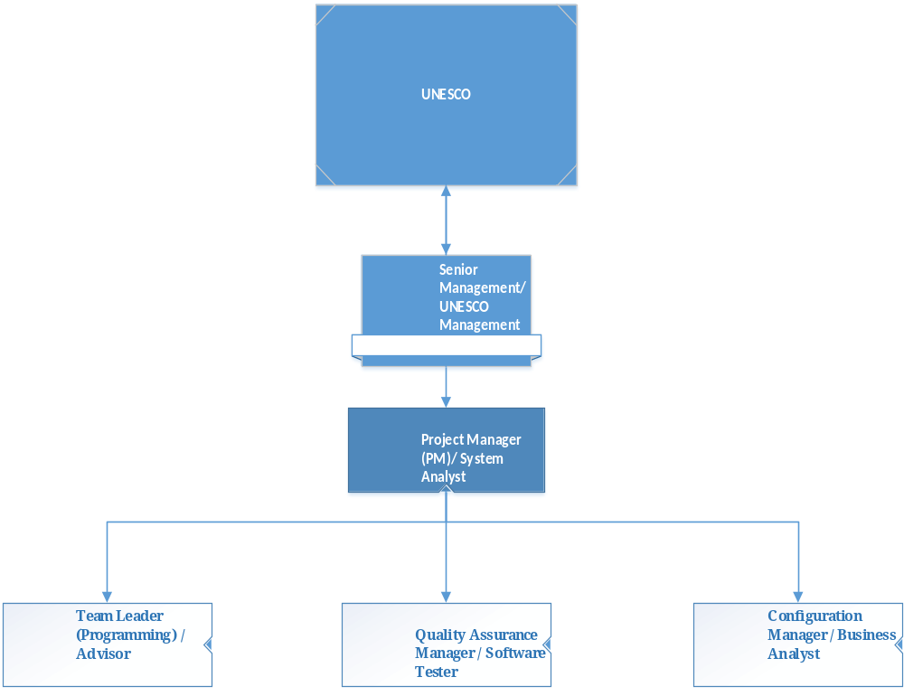
Figure 1. OERTP Organization Chart
Project Manager/ System Analyst/ Developer

Task: Produce and maintain a project management plan and lead the project according to this plan thus ensuring that the product is delivered on time and as specified in the Software Design Descriptions and Software Requirements Specifications Plan.. The PM’s management task includes but is not limited to:
- Motivating team members;

- Forming teams and assigning tasks;

- Checking progress;
- Managing the time budget;

- Defining work packages and goals;

- Providing feedback to the SM through progress reports.
- Coding of the project where ever necessary.
- Configuration Management whenever necessary.
- Working on the software development for the project.

Quality Assurance Manager/ Software Tester / Developer

Task: Guarantee that the product will be delivered as agreed and that it is of good quality. This includes but is not limited to:

- Maintaining the SQAP;
- Verifying that procedures and standards which are defined in the SQAP are adhered to;

- Checking that all project documents are consistent;

- Arranging formal reviews;

- Monitoring and reviewing all testing activities.
- Working on the software development of project.

Configuration Manager / Business Analyst/ Developer

Task: Perform version management for documents and code. This includes but is not limited to:

- Maintaining the SCMP;

- Creating a repository for all documents and code;

- Checking that the repository is used appropriate (that is according to the SCMP) by all team members;

- Maintaining the repository according to the SCMP.
- Working on the software development of project.

Team Leader/ Trainer/ Developer

Task: Perform all necessary activities to ensure that a task assigned to a team is performed well and on time. This includes but is not limited to:

- Planning and coordinating team activities;

- Providing feedback about team progress to the PM;

- Motivating team members;
- Chairing reviews of the items made by his team.
- Training the team in Drupal 6 and 7 framework.
- Working on the software development of project.

Team Member(s) in general:

Task: All the members of the team except the Senior Manager, perform all necessary activities to ensure that a task assigned to a team is performed well and on time. This includes but is not limited to:

- Assisting the TL or PM by signaling problems in an early stage;
- Executing plans made by the TL and by the PM;
- Keeping track of time spent on various tasks;
- Following procedures and plans.

Software Configuration Management Structure
The basic methods and overall functionality followed involved in Configuration Management process is as shown in the Figure2.
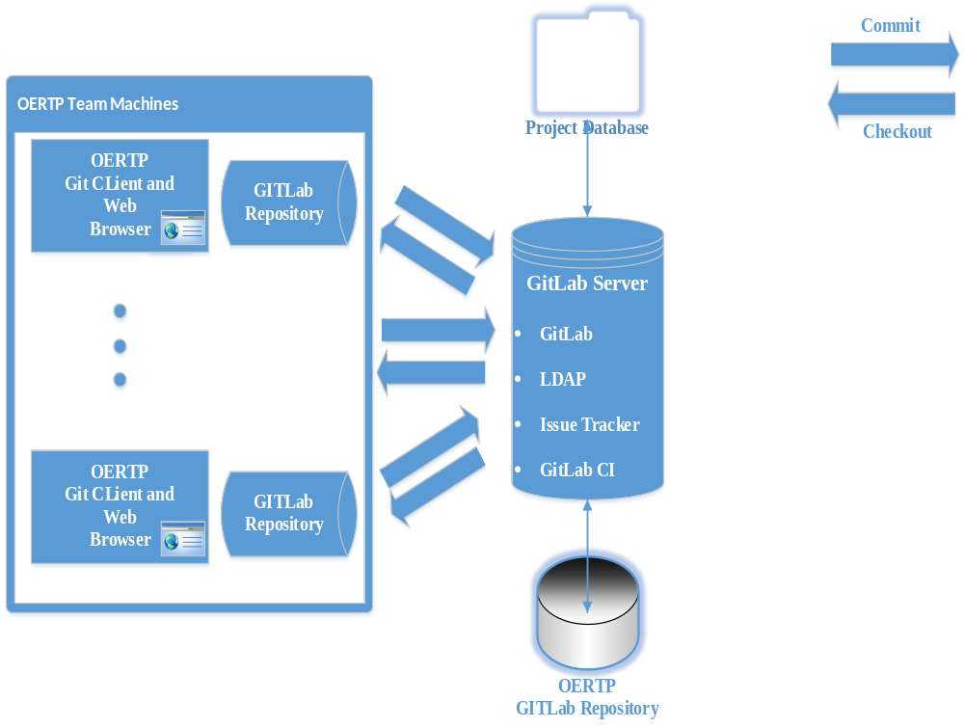
Figure 2. GitLab CM Overview
Figure 1. Configuration Audit Activity Model
The remainder of this CMPT describes the membership and basic activities of Project Configuration Management. The project CMP will summarize their scope of authority and refer the reader to documents which detail their membership and activities.

SCM Roles and Responsibilities
Project success relies on good communication between internship contractors and UNESCO. This plan facilitates efficient communication required to approve and implement changes by clearly defining the role each organization plays in the CM process. Table 1 provides a visual matrix of the responsibilities that each role is assigned for a given activity. A description of each activity, responsibility, and role follows the matrix. Project CMPs which add SCM activities or roles will summarize them in this section using the same matrix/description format. The project CMP will assign its new activities to one or more roles with an elaboration of the role’s responsibilities within the activity. The project CMP will assign new roles to members of the project organization it presents in section 2.1.1.

Roles   ------------------------  Activities  | CCB (Senior Management) | Project Manager, PM | Business Analyst, (Configuration Manager) | Quality Analyst (Software Tester) | Members of OERTP Team | Team  Leader, TL | Customers
Change Request | Submit  Review  Approve | Submit  Review | Submit  Review | Submit  Appeal | Submit  Appeal | Submit  Review | Submit
Change Implementation | Perform  Review  Approve | Perform  Review | Review | Assign | Authorize
Change Control | Enforce  Perform | Perform |  | Enforce
Configuration Identification | Perform  Approve | Perform
Documentation | Perform  Approve  Maintain | Perform  Maintain
Status Accounting | Perform | Perform
Audits & Reviews | Perform  Approve | Perform | Perform  Approve |  |  |  | Perform  Approve
Table 2. Responsibility Assignments for Project SCM Activities

Activity Definitions
Change Requests - CRs represent either the identification of CI defects or a request for enhancement of a configuration item. CRs for project is written (submitted), reviewed, approved, and sometimes appealed (see section 3.2 and Appendix A).
Change Implementation - Once a CR is approved and PM or TL has authorized work on behalf of it, implementation of the requested change is assigned to a group or individual (see section 3.2.6 and the OERTP Software Development Plan).
Change Control - Changes cannot be introduced without approval. Each change will be screened to verify that it implements only an approved CR (see section 3.2.6).
Configuration Identification - Items (software, documentation, and resources) under control of the plan must be identified and named (see section 3.1).
Documentation - Documentation encompasses any text generated in support of the project. It includes but is not limited to design documents, source code documentation, test reports, CRs, status accounting reports, and audit reports.
Status Accounting - Status accounting gathers and reports information concerning the tracking of CRs, change implementation, and CI contents (see section 3.3).
Audits & Reviews - Audits and reviews verify that OERTP CIs contain all and only all changes from closed CRs that they adhere to OERTP standards, that the framework matches its documentation, and that any distribution of the framework is complete (see section 3.4).

Responsibility Definitions
Approve - The organization/individual approves requests for an activity and/or its results. More than one approval may be needed. This responsibility may be delegated temporarily or permanently to another individual within the same project organization.
Assign - The organization/individual is responsible for assigning the activity to a developer. This responsibility may be delegated temporarily or permanently to another individual within the same project organization.
Authorize - The organization/individual authorizes resource expenditures for the activity. This responsibility may be delegated temporarily or permanently to another individual within the same project organization.
Enforce - The organization/individual is responsible for exacting compliance with all policies regarding the activity.
Maintain - The organization is responsible for upkeep of products associated with the activity.
Perform - The organization is responsible for carrying out the activity.
Review - The organization is responsible for examining products required by an activity for completeness, correctness, and clarity. This organization may also be responsible for identifying missing information.
Submit - The organization/individual can submit a CR.

Role Definitions

The OERTP Project CCB
The configuration control board (CCB) for the project has primary responsibility for reviewing, approving, and assigning changes to the project’s requirements and products. The Project CCB shall include the Senior Management(SM), Manager (PM) and the Team Leader (TL) and Configuration Manager (CM). All CCB members are technical analysts who review change requests. CCB members perform the following configuration activities:
- Implement approved changes.
- Review approved changes. According to the OERTP Project Management Plan, all class designs must undergo review and all source code changes are subject to a code walk-through. During these reviews, CCB members shall verify that only the requested change is being made and that it has been implemented according to OERTP standards.
- Create or amend required documents.

Business Analyst
The Business Analyst has the following responsibilities:
- Authority to approve change requests.
- Determines when sufficient information is available to make the approval decision.
- Decides whether a CR review requires a formal meeting of the CCB or an informal discussion with some team members.

Project Manager
The Project Manager has the following responsibilities:
- Administer the CR database, performing periodic maintenance and coordinating new customizations.
- Verify that all CRs are complete and properly submitted before promoting them to review (see section 3.2).
- Deliver implementation assignments for approved CRs (see section 3.2.6).
- Verify that CRs are complete with proper authorization before closing them (see section 3.2.8).
- Produce all configuration status accounting reports (see section 3.4).
- Prepares agenda and records minutes for the formal CCB meetings.
The Configuration Management Procedures for OERTP Project further elaborates the responsibilities of the Project Manager.

Senior Management
The Senior Management has the following responsibilities:
- Administer the project’s CI repositories, performing periodic maintenance and coordinating minor customizations.
- Give CR implementers write access to the repository.
- Ensures that only reviewed and tested changes become visible to developers (see section 3.2.8).
- Define each new release of a project CI (see section 3.1.2).
- Create repositories for new CIs (see section 3.1.3).
The Configuration Management Procedures for Project further elaborates the responsibilities of the CM.

UNESCO Management
The UNESCO Management consists of the OERTP Senior Management and the OERTP Team Leader. They can submit CRs to the project’s CCB. They assist the CCB in enforcing change control procedures through their support of the CM process. They resolve appeals on CRs which were submitted by internship contractors (see section 3.2.5). UNESCO Management also approves in-process audits (see section 3.4.3).

Applicable Policies, Directives, and Procedures
In addition to the CM policies detailed in this document, the following external standards and procedures apply for the duration of the project:
- The OERTP Project Configuration Management Procedures details how SCM software is used in support of this plan.
- The Drupal 7 version - Programmer’s Guide, which specifies stylistic and programming conventions, shall be followed for all source code written as part of a OERTP CI. These guidelines include but are not restricted to source code file names, variable names, structured code formatting, and class design restrictions. The guide's purpose is to ensure uniform looking code that is readable and avoids dangerous language idioms. Code changes shall not be accepted unless they conform to this document.
- The OERTP Software Development Plan discusses the software lifecycle and proper testing procedures. All directives in this plan must be adhered to before a code change is accepted.
If the project has any other documented policies that affect SCM activities (e.g., security plans), they will be listed here.

Activities

Configuration Identification
A completed software product will include a large variety of controllable components: requirements documents, design documents and drawings, source code, make files, test suites, test plans, technical descriptions (a.k.a. source code documentation), end-user documentation, input data (e.g. aerodynamic data), etc. Moreover, each of these items matures at different stages of the software’s development cycle. Configuration identification takes these considerations and produces a configuration control “map” for the software’s development. This map:
- Breaks the software product into smaller, more manageable pieces which usually have unique configuration management needs. These pieces are called configuration items (CIs).
- Defines the control points (a.k.a. baselines, updates, or versions) for these CIs. Baselines are defined by their contents. During the initial stages of a software product’s development, each successive baseline will contain progressively more types of controllable components. Once a software product reaches production, the types of controllable components are usually frozen and each baseline represents a set of changes or additions to the already existing types.
- Provides a labeling scheme which links together the contents of a baseline.
- Addresses how CIs are to be acquired and placed under control.
The following configuration identification scheme requires that all components of a project CI be placed under the control of SCM software; therefore, all CI components must exist in electronic form. This makes configuration identification easier. Traditionally, drawings, documents, and source code were all handled and labeled differently because each was created and controlled as different media. The uniform storage and control of all CI components under SCM software allows for the application of identical controls and labeling.

Identifying CIs
CI identification must be tailored for each module. The number of CIs identified should reflect project lifespan and complexity. A CI can represent a distinct product of the project. For example, a project may determine that the visual displays and the Drupal Module should be separated into two CIs. A CI could also represent a long-lived variant of another established CI. Rather than control the variants under individual CMPs. It is more efficient to place all of these related projects under one CMP which treats each variant and the base as separate CIs. In this latter case, the CM plan will contain provisions for moving changes from a variant into the base or into another variant (see section 3.1.1.1).
Table 3. OERTP Project Baseline Contents
Baseline | Contents
Functional | OERTP Project Requirements
Designed | Design Documentation
Batch | Source Code  Makefile  Unit Test Suites
Checkout | Integration Test Suites
Production | Real-time Test Suites  User documentation (if required).
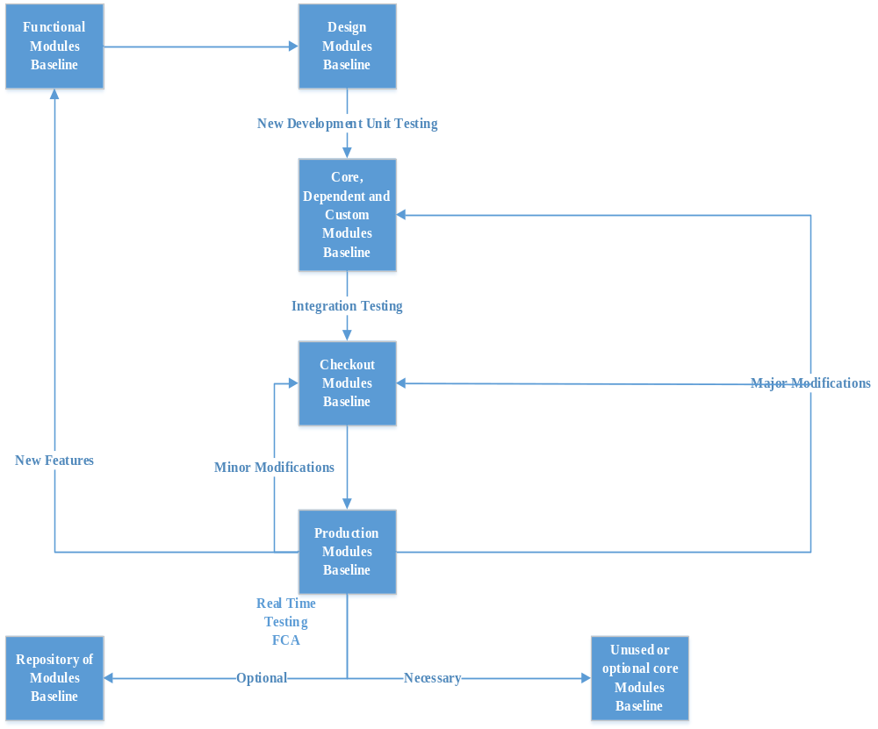
Figure 2 OERTP Project Baselines
The functional baseline represents the project’s requirements and processes. All documents containing project requirements or describing the project-unique development processes are labeled as functional baseline components. At a minimum, the functional baseline is embodied in the Project Request (PR) and the project’s CMP. A new functional baseline is established whenever a change in the project’s requirements or development process occurs. These changes generally concentrate at the start of the project but can occur anytime within the project’s lifespan. They include (but are not limited to):
- Modification or addition of a project-unique development process. In addition to the project CMP, a project may have tailored security plans, test plans, and operation procedures.
- Granting a deviation or waiver. During the course of analysis, design, or implementation, the development group may determine that a requirement cannot be met as stated. If a slight variation of the requirement can be met, then a deviation is granted. If the requirement cannot be met at all, then a waiver must be granted. A note describing this action is added to the appropriate requirements document(s).
- The customer modifies a requirement. A note of this modification is added to the appropriate requirements document. These customer modifications usually take the form of enhancement requests.
- A new feature is requested and approved. New features represent new requirements. The documents describing the new feature are added to the functional baseline.
Design may proceed once the functional baseline is established. The design baseline includes the complete set of design documents and Unified Method diagrams upon which the source code development is based. Good object-oriented analysis prioritizes requirements and creates an incremental build strategy for the project. The first design baseline will describe the incremental build which will support the first experiment. This baseline is established when all the relevant designs have been reviewed and approved by the SM. Subsequent design baselines contain design additions or modifications which have been reviewed and approved. These changes include:
- Designs describing features for a subsequent incremental build.
- Design changes in response to requirements changes.
- Design modifications which evolve from implementation experience. The developer may discover that the original design is inefficient or inflexible. He may propose a design change (using a CR). If approved, the design document is updated and attached to the baseline.
The batch baseline contains code which is ready for integration testing in a non-real-time environment (a.k.a. “batch” testing). All new development and unit testing occurs prior to establishment of a batch baseline. Source code does not come under formal CM control until it associated with a batch baseline. The batch baseline includes all the unit test suites created during new development. The first batch baseline does not have to represent the first incremental build. It can be any combination of unit-tested subsystems that have undergone a code review (see section 3.4.1) and are ready for integration. Subsequent batch baselines are established with the addition of new unit-tested subsystems or major modifications to existing subsystems. Major modifications need regression testing using the appropriate unit and integration test suites. Identifying a major modification is subjective; the SM categorizes the size of a change during the code review (see section 3.4.1).

A historical baseline is created when a research experiment requires a small one-time change to a past production baseline. The historical baseline will either be a “dead end” or will eventually be folded into mainline development. Except for configuration labeling, a historical baseline will be treated as a production baseline; it is created after an FCA of the required modifications. Under no circumstances does a historical baseline become a more involved development effort. Research requiring major modifications or multiple incremental changes to a past production baseline should be categorized as a variant project of the base project.
The baseline progression presented here does not imply a only waterfall or agile development cycle but a combination of both. This is most evident in the many paths development can take as it progresses to and from production baselines. For example, a change made to a production baseline can become either a batch or checkout baseline depending on its scope. A change branching off of a checkout baseline can revert back to a batch baseline. Also, any given baseline does not need to be fully established before work on its successor can begin. New development and unit testing can be done for technical demonstration before the design baseline is established. Not all subsystems need be complete before the first checkout baseline is established. The only hard rules of baseline progression are as follows:
- No design work will begin until the first functional baseline is established.
- The first instance of a baseline cannot be established until its predecessor has been established. However, work leading toward the creation of a baseline may begin before the predecessor baseline has been established (except as noted elsewhere). For example, the first batch baseline cannot be established until the first design baseline is established. Coding and unit testing may begin before establishing the design baseline, but no integration testing, the “signature” of a batch baseline, will begin until the first design baseline is established.
- The first session baseline must contain the minimum subsystems required to run a researcher experiment, i.e. the first incremental build.

Naming CIs
The CI labeling conventions rely on the final baseline system created for the project’s configuration management plan. CI release labels contain enough information to relate labeled objects with a particular baseline of a particular CI in a particular project. The release label is attached to all the components of the CI and can be the sole indicator of the CI to which a particular component belongs. (How this is done is implementation specific and is discussed in the Configuration Management Procedures for OERTP project.) This section provides a CI naming convention for the template baseline system presented in section 3.1.1 as an example. Project CMPs, which contain additional baselines, will create labeling conventions for those baselines in this section. The project-specific labeling scheme shall be consistent with this template system.
A release label will use the Module number to relate a CI baseline release to a particular project. A project’s CMP assigns a unique alphanumeric code to each CI it controls (see section 3.1.1). A release label will use this code to identify the CI to which it refers. Lastly, the CI release label will contain a character code that identifies the current baseline progression. Table contains a matrix for forming release labels. In the matrix, literal text is enclosed in quotes. The label content descriptions follow the table.

Baseline | Version Label Contents
Functional |  |  |  |  | ‘FUNC’ |  |  | Revision
Design |  |  |  |  | ‘DSGN’ |  |  | Number
Batch |  |  |  |  | Session |  |  | Checkout |  | Batch
Checkout | Module | ‘_’ | CI Code | ‘_’ | Revision |  | ‘.’ | Revision | ‘.’ | Revision
Session | Number |  |  |  | Number |  |  | Number |  | Number
Maintenance |  |  |  |  |  | Historical  Session  Letter
Run-time |  |  |  |  | Date Stamp
Table 4. Baseline Naming
Module Number The Project Manager assigns a module number to each module project once the project is approved. Under CMPs covering related projects where each project is treated as its own CI.
CI Code a project must assign, to each CI, an uppercase alphanumeric code no longer than four characters. For CMPs that control related projects as CIs, this code will be the same as the Module numbers. The CI code is optional for CMPs that control only one CI.
Revision
Number Functional and Design baselines are given an integer revision number. The initial baseline is given a revision number of one. Each subsequent change to these baselines increases the revision number.
Session Revision
Number This integer increases with the establishment of each new session baseline. It is initialized to zero indicating that the first session baseline is still under construction.
Checkout Revision
Number This integer increases with the establishment of each new checkout baseline. The integer reverts to zero whenever the session revision number is increased. The number is initially zero to indicate that the first checkout baseline is still under construction.
Batch Revision
Number This integer increases with the establishment of each new batch baseline. The integer reverts to zero whenever the session or checkout revision numbers are increased. The number is initially set to zero indicating that the first batch baseline is still under construction.
Historical
Session Letter Each historical baseline is identified by this session letter. The session revision number of a historical baseline remains constant as a reminder of the production baseline from which it originated. The historical session letter then increases with each new historical baseline that emanates from the same production baseline. The letter is lowercase and is initialized to ‘a’. (Since a historical baseline is always derived from a production baseline, the batch and checkout revision numbers would always be zero; therefore, it is not necessary to record them.)
Date Stamp Run-time baselines are tagged with a time stamp of the form MMDDYYYY-HH. MMDDYYYY is the month-day-year on which the session took place. HH is the military hour in which the session began. For example, the run-time baseline representing changes which occurred during the 2:00 PM production session on January 14, 2014 would receive the following time stamp: 01142014-14.
A base project with variants represents a special situation. The variants are given their own dedicated project. As stipulated in Section 3.1.1, only one CMP is necessary to control related projects; the CMP will treat each project as a separate CI. In this case, the CI codes will be the same as the Module numbers. The “Module number” portion of the release label will be replaced by the name of the Drupal Module being modified (e.g., F18e).

This document does not provide explicit naming instructions for the versions of individual CI components. It is assumed that this function is handled by the version control software and shall be identified in the Configuration Management Procedures. Additional notes about naming components of a given type are presented below:
- Documents. Requirements, design, technical, and end-user documentation shall all contain the Module number in their title. All documents are to be stored in electronic form in a version controlled repository. Documents will be part a CI if they describe the CI or any of its components; otherwise, documents will be controlled as their own CI. Many documentation changes relate to source code changes and are considered part of the CR requesting the code change; the CR is not closed until both source code and documentation have changed. Documents are considered a critical part of the CI to which they belong; documentation changed without need to change source code (or other CI elements) can create a new baseline release.
- Test Suites. Test suites are attached to the software CI for which they were designed. They shall be stored in the same repository as the software product, and they receive the same release label as the software product. A revision to a test suite is not considered a revision of the CI and does not prompt a new release of the CI. Test suites are support code for enhancing project quality; they do not represent the software product. When a test suite is revised and accepted, the new revision will receive the release label of the last CI release. (This process removes the release label from the previous revision of the test suite.) The OERTP Software Development Plan and the OERTP Developer’s Guide contain more information on creation and maintenance of test suites. These provisions should not give the impression that configuration control of test suites are not important. Test suites are a focus of attention during functional configuration audits (see section 3.4.2).
- Source Code, Makefiles, and Input Data. The naming guidelines for these components are dictated in the Drupal 7 Documentation online. Attachment to a CI is implied through directory structure and release labeling.
- Unified Method Diagrams - Because of the capabilities of modern OOD/OOA tools. These object-oriented design diagrams can have a dual purpose. If the diagram is being used to generate code, then it is treated as source code. If the diagram only serves to illustrate the design of production code, then it is treated as design documentation. (In many instances the OOD/OOA diagrams may transition from one use to the other.)

Acquiring CIs
All CIs under control of the same CMP will reside in the same repository. The Configuration Management Procedures covers repository setup and use in more detail. When a CI is identified, a logically isolated portion of the project repository will be created for it. The initial contents of the CI will include the functional requirements extracted directly from the Project Request and any supplemental documentation (including CRs). [Some projects may incorporate source code from outside sources; this code will also be placed in the repository.] All new CI files will be created and controlled in the repository. Only the CM and the LAN administrator will have full privileges to access and manipulate the repository. All others will be granted permissions appropriate to their CM responsibilities. The repository will be backed-up onto DMSS daily. At a minimum, a different backup will be generated for each day of the work week and these will be recycled weekly. The backups will be given the file name ProjectNumber.day_of_week.tar.gz. Actual backup procedures will be set by the LAN Administrator under Functional Coordinator approval. The SCM database itself already guarantees that any previous version of a component may be retrieved at any time; thus, old backups do not need to be maintained indefinitely. The backups are a measure that prevents lost work due to abnormal server termination or SCM repository corruption. When the project ends, a final backup of the database will be made and stored indefinitely or until UNESCO orders its destruction. If a project has unique concerns for acquiring, controlling, storing, and retrieving CI objects, they will be listed here.

Configuration Control
This section describes the configuration control activities which request, evaluate, approve/reject, and implement changes to CI baselines. All projects will follow the activities detailed in this CMPT. Projects are free augment these activities in their CMP.
If a project CMP adds baselines to the template, then change authorization for those baselines must be explained in the following sections. The remainder of this section discusses configuration control activities for the template baselines.
Change requests (CRs) can be submitted against functional, design, checkout, and production baselines. Batch baselines are considered works-in-progress and forcing change authorization would only hinder the development process.
Technically, checkout baselines are also works-in-progress. However, checkout baselines are used for real-time testing and functional configuration audits (FCAs). They have already undergone significant unit and integration testing so defects should be few.
Moreover, CRs act as a deterrent against changes hastily made during the short span of a real-time session. Such changes are likely to be poorly designed and frequently fix the symptom of a problem instead of its root cause. Even worse, these changes are more easily lost. CRs also offer a convenient means of recording the results of FCAs. Historical baselines are one-time changes.
A CR is submitted to create an historical baseline but a CR cannot be submitted against it. Similarly, CRs are not submitted against run-time baselines. Run-time baselines simply record changes made during a production real-time session.
No further development is spawned from them; they are “dead-end” baselines. However, CRs can be submitted against a session baseline to incorporate the changes represented by historical or run-time baselines.
A project CR has seven stages in its life cycle:
- Submittal - for requesting changes
- Review - for evaluating change requests
- Approval - for approving or disapproving change requests
- Authorization - TEAM authorizes the labor and/or expenditure required to implement the CR.
- appeal - for appealing forward or rejection decisions of the CCB
- Execution - for implementing and reviewing changes
- Closure - for closing the CR

The project CM will ensure that complete records are received at each stage. Each CR will contain a status field that indicates it current progression through the lifecycle; the valid status values are:

Submitted The change request has been received and given a CR number.
Reviewed The CR has been reviewed by the CCB.
Approved The CR has been approved by the CCB.
Authorized TEAM has authorized the labor and/or expenditure required for the CR and the CCB has assigned the CR to an engineer for implementation.
Implemented The CR has been implemented and the implementation has been accepted.
Deferred The Senior Management or Business Analyst, (Configuration Manager) has determined that an approved CR has too low a priority for immediate allocation of project resources. These CRs usually represent wish list items that are implemented on a time available basis.
Duplicate It has been determined that the CR is a duplicate of another CR.
Forwarded It has been determined that the CR goes beyond the authority of the project CCB and has been forwarded to the proper CCB.
Rejected The CR has been rejected by the CCB.
Appealed A rejection or forwarding decision has been overturned by developers of OEROTP or Functional Coordinator.
Denied TEAM has refused to authorize the labor and/or expenditure required for the CR.
The following subsections describe the activities in each life cycle state and illustrate when each of the status values can be applied to a CR. Figure 3 gives an overview of the CR lifecycle assuming that the CR follows the most formal process detailed in this section.

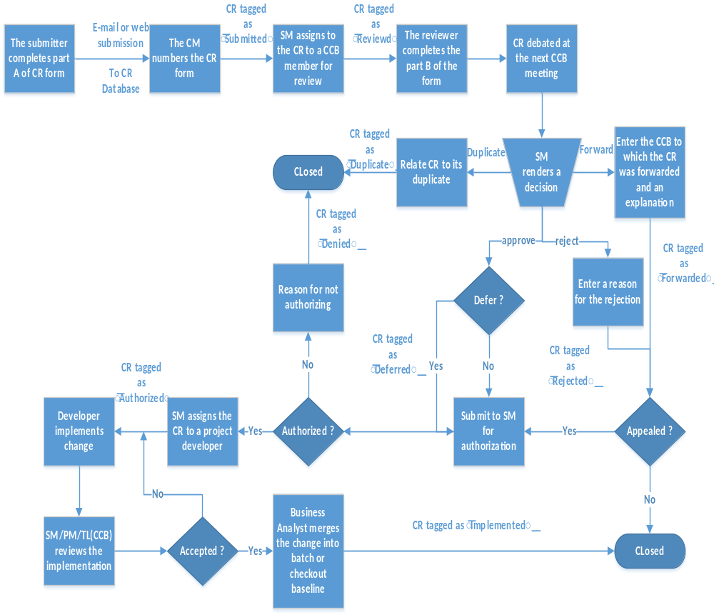 Figure 3. Project Change Request Lifecycle

Submittal (Requesting Changes)
Project change requests (CRs) may solicit requirements modifications, requirements waivers, functional enhancements, design modifications, additional documentation, or defect corrections. CRs may be submitted by developers or researchers involved with the project. The CR form requirements appear in Appendix A. There is no “official form”; just an official list of the data that will appear in the form and its general organization. All CRs will be submitted electronically to a defect tracking software product. Most modern defect tracking products allow limited formatting of their CR printouts; therefore, presentation of completely formatted “official form” seems inappropriate. The submitter needs to supply the information listed under Part A of the form. This section records contact information and a summary of the request and its purpose. The submitter shall also provide enough information to reproduce a defect or to test an enhancement/modification (if applicable).
Once a CR is received by the CCB, the other UNESCO authorities (or the CR tracking software) assigns a CR number to the request. If possible this number should be of the form Project Number-#, where # is a whole number. A CR achieves the ‘submitted’ state only when it receives this number. From this point forward, the submitter will be notified by e-mail of all status changes to his CR. It shall take no longer than one month to address a submitted CR. If no activity on a CR is observed, the submitter should contact the CM.

Review (Evaluating Changes)
A CR reaches the ‘reviewed’ state when the project CCB actively evaluates it. The following paragraphs illustrate the most formal process that a CR may take when under review. At the SM’s discretion, short cuts may be taken anywhere in this process. For example, a defect which is known to require ten lines of new code to fix could simply be approved by the SM without any more review than the time it took him to read the CR. Should the CR review require some discussion, the SM does not have to call a formal meeting or approach all the members. The SM decides how best to obtain the information he needs to make an informed decision. However, the CCB will formally meet at least once a month to review all outstanding CRs.
On the first Monday of each month, the CM will identify all outstanding CRs. The CM and the SM will assign each CR to a CCB member for review. The assignment guarantees that at least one person will examine the CR; but it does not prevent other CCB members from doing the same. The entire CR list plus the reviewer assignments will be sent to all CCB members along with an announcement of a formal CCB meeting the following Monday. The CR list will be ordered according to priority and will represent the agenda of the Monday meeting. If other issues are to be discussed at this meeting, they shall be listed in the e-mail. The reviewer will analyze the CR form focusing on its impact to program cost or schedule and uncover any technical risks. If the CR identifies a defect, the reviewer will verify the reproducibility of the defect. The reviewer will record his findings on Part B of the CR form and mark the CR as ‘reviewed’. Any additional costs must be approved by TEAM management (see section 3.2.5).
At the formal meeting, each CR will be addressed as per the agenda. The assigned reviewer will make a recommendation; then the floor will be open for debate. All attendees are welcome to join in the debate. The SM alone decides when to end the debate; he then will issue his decision on the CR (see section 3.2.3). Under no circumstances will a CCB meeting last more than two hours. If the agenda cannot be addressed in the given two hours, then another meeting will be scheduled no earlier than the following business day. (It is recommended that the meeting be scheduled for the following Monday.)

Approval (Approving or Disapproving Changes)
The SM will render a decision on a CR when he feels he has sufficient information.
Part C of the CR form records this decision. The SM can make one of four decisions: ‘approve’, ‘reject’, ‘forward’, or ‘duplication’. The result of each decision follows:
Approve The CR is marked ‘approved’. The SM now has another choice. The CCB i.e., Functional Coordinator may defer the CR (see section 3.2.4) or pass the CR to TEAM for work and/or expenditure authorization (see section 3.2.5). The Functional Coordinator may contact the submitter for suggested modifications to the CR form before approving a request. The submitter is required to send e-mail acknowledgment that he concurs with the modifications. This e-mail will be attached to the electronic CR record.
Reject The CR is marked ‘rejected’. The SM must record a reason for the rejection in Part C of the CR form. The CR is considered closed pending appeal (see section 3.2.4).
Forward It has been determined that the requested change is beyond the authority of the project CCB. The CR will be tagged as ‘forwarded’ and sent to the appropriate CCB. This CR is considered closed from the project CCB’s perspective. The forwarding decision can be appealed (see section 3.2.4). (This avoids a potential loophole that provides a way to avoid appeals on rejected decisions.) The SM will name the CCB to which the CR has been forwarded and provide an explanation for the decision.
Duplication It has been determined that the requested change is a duplicate of another change request. Two forms of duplication exist: identical and functional. Identical duplication indicates that the change request is a near copy of a previous change request. Functional duplication means that the change request represents a different symptom of the same defect or a different spin on a new feature or enhancement reported in a previous change request. The change request is marked as ‘duplicate’. The submitter is added to the notification list of the “original” CR. A pointer to the original CR will be added to the duplicate.

Deferring a CR
The SM can approve a CR and then defer it. The CR is tagged as ‘deferred’. The SM must state his reason for deferring the CR on the CR form (part C). A deferred CR has the lowest priority; it is performed on a time-available basis only. This status is usually reserved for ‘wish list’ changes. Deferred CRs are not necessary to complete project goals. They contain non-critical changes that enhance usability or fix very minor annoyances. Sometimes customers request a feature that they would like to explore in the future if the project’s primary goals are reached ahead of schedule. A deferred CR remains in limbo; it is not sent to TEAM for authorization. A deferred CR can be revived under these conditions:
- A developer volunteers to implement the CR and the Project Manager concurs.
- The Project Manager assigns the CR as a training exercise for a new employee.
- The project elevates it to a required change.
Once activated, the deferred CR is sent to TEAM for authorization. The TEAM authorizer also has the power to defer any CR (see section 3.2.6), whether or not that CR had previously been deferred by the SM. A CR deferred by TEAM is no different than one deferred by the SM. Any deferred CRs remaining when the project is closed are immediately marked ‘denied’ by the TEAM authorizer. The TEAM authorizer can type ‘project closed’ as the reason for denial.

Appealed (Overruling Rejection or Forwarding)
The decision to reject or forward a CR may be appealed. If they decide to do so, then the CR will be marked as ‘appealed’ by the overruling manager and submitted for work/expenditure authorization (see section 3.2.5). This holds regardless of whether the initial decision was to forward or reject.
Only the submitter may file the appeal. There is no form for appeals. The submitter must simply send an e-mail which references the CR by number and which states his reason for appeal. All other appeals are sent to the TEAM Assistant Branch Head. If first level of management decided in favor of the CR submitter, the SM has the right to appeal that decision to the second level. Decisions at second level of management are final. Throughout the appeal process, the SM must be listed for carbon copy reception on all correspondences regarding the appeal, including the initial letter of appeal.

Authorization
All contractor work and expenditures must be approved by TEAM. TEAM represents the project’s interests. TEAM decides whether it is appropriate to charge the project for implementing the CR. Authorization is also TEAM’s main instrument for influencing project changes. It serves as a check against SM decisions. TEAM’s actions can cause a CR to be implemented, rejected, or deferred. TEAM Management may select no more than two staff members who will share the responsibility of authorizing work and expenditures for CRs. The project Facilitator may be one of these persons. Part C of the CR form will contain fields for TEAM authorization of work and expenditures. TEAM may refuse to authorize the work and/or expenditure. This, in effect, rejects the CR. The status field ‘denied’ differentiates this rejection from that of the SM. The TEAM representative refusing the authorization will enter the reason on the CR form. Reasons for refusal are as varied as those for the SM. A ‘denied’ CR is closed. TEAM can choose to defer the CR. The CR is marked as ‘deferred’ and can be resubmitted for authorization at a later date (see section 3.2.4). TEAM will enter the reason for deferral in on the CR form and return the CR to the OERTP CCB. Team members for deferring a CR can include (but are not limited to):
- Defer any purchases required by the CR into the next fiscal year.
- If not satisfied with the reviewer’s analysis of the CR. It can ask for a broader investigation which will take more than one business day to complete. CR’s requiring a purchase authorization will commonly fall under this reason.
If CCB the CR, the SM will assign the CR to an engineer for implementation. The CR will then be tagged as ‘authorized’.

Execution (Implementing changes)
The developer is granted change authorization when he receives an authorized CR. The programmer creates a “developer baseline” which contains the CR implementation. The developer baseline will be based on the baseline against which the CR was logged (usually a checkout or session baseline). Requirements changes will result in a new functional baseline. Likewise, design changes result in a new design baseline. Source code changes will result only in a new batch or checkout baseline; only small changes should move directly to a checkout baseline. Developer baselines will never be directly folded into a new session baseline because the changes must undergo an FCA first (see section 3.4.2).
When the programmer has tested his changes and is satisfied with the results, the developer will fill out part D of the CR. Part D describes the actions taken to make the change and the actual impact on cost, schedule, and resources. The names and versions of the modified CI components (if any) shall be recorded with the CR. The developer will then contact the CM to schedule a code review. The review process is described in the OERTP Software Development Plan and is conducted by the CCB. Once the change passes the review, the change request is ready for closure.

Closure (Closing the CR)
A rejected, forwarded, or denied CR is considered immediately closed and no further action is taken on it. The closure procedures for an authorized CR begin when the CCB Librarian receives the completed change from the review board. Requirements and design changes are merged directly into the appropriate baseline. Source code changes are folded into a new batch baseline unless the review board rules that the change may be used to create a new checkout baseline. Once the change is merged, the developer and the CCB Librarian will complete part E of the CR form, and the CM will tag the form as closed. The CM will announce the new baseline to all project participants in an e-mail which includes a CR summary (see section 3.3.2.1). This informs all project developers, who are using the batch or checkout baselines for testing, that a new change has been added.

Configuration Status Accounting
Configuration status accounting is the process that provides for traceability of changes to the software and hardware. It ensures that status is recorded, monitored, and reported on both pending and completed actions affecting the CIs. This section defines the configuration data which is to be tracked. It specifies how the data is to be stored and what access controls will be applied to the data. This section also identifies the required configuration status accounting reports and outlines their contents. Project CMPs can expand the list of data to be collected or the types of reports generated.

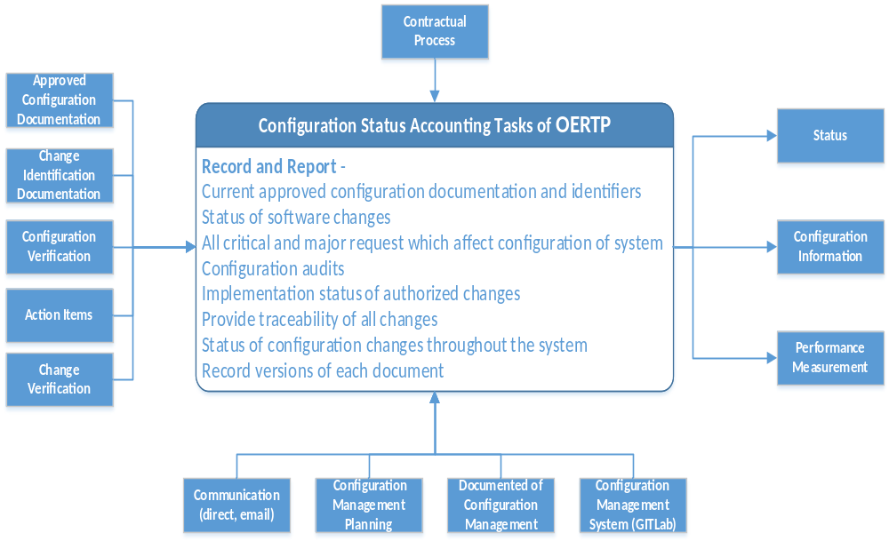
Figure 5. Configuration status accounting of OERTP

Configuration Data
All configuration data will be stored electronically in either the CR or CI databases. Much of this data can be obtained by project developers and users through automated interaction with the SCM software. The version control and CR tracking software will be customized to generate or prompt for critical data. Despite the level of automation possible, some data must be manually entered into the system. The CCB is responsible for ensuring that all necessary data is collected. This entire plan has been written to avoid the recording or transfer of data on paper. Whenever possible, configuration data shall be received through an electronic media such as e-mail. Centralized electronic storage prevents loss of data and can easily be backed-up.
Appendix A defines the mandatory information that must be recorded in each CR. In addition, this CMPT assumes that the version control software records the following information, at a minimum:
  - For each file changed or created,
    - The person who made the change.
    - The date the change was made.
    - The reason for the change. This is a meaningful comment supplied by the person identified in (a).
    - The number of the CR for which this change was made.
    - The lines or bytes in the file which were changed.
  - For each version label created,
    - The person who created the label.
    - The date the label was created.
    - The reason for the label’s creation. This is a meaningful comment supplied by the person identified in (a).
    - The file versions to which the label was attached.
Read access to the configuration data should be freely granted to project developers and customers within UNESCO. Only with written authorization from the SM and or PM, can read access be granted to third parties. However, some projects may have special security requirements. The project’s CMP will specify who will freely access the system. Write access to the configuration data shall be granulized such that only those persons with authority to change a data item (as specified in this plan) are granted write access to that item. This is particularly important for electronic signatures on CR forms.

Configuration Reports
Configuration reports convey the status of the project configuration. CR database software usually provides a pre-packaged set of reports and the ability to create custom reports. Read access to the CR database should be freely given so that members of the development community can extract status information and metrics to meet their unique needs, security requirements notwithstanding. The remainder of this section details the three reports that the project CCB must release as part of their CM activities. These reports are the CR summary, release notes and the monthly CR status report. These reports sufficiently inform the development community of completed and pending changes.
The contents of these reports are described; but, as with the CR form, no specific format is given. The exact format of the reports is dependent on the capabilities of the reporting function in the CR tracking software. The focus of this process is to inform project members of CM developments, not to give the CM the work of creating additional scripts which will automatically format each report according to someone’s arbitrary vision. It is recommended that when these reports are issued, a copy be e-mailed to all project developers and interested parties in management. The CM is charged with creating and distributing these reports.

CR Summary
A CR summary is issued whenever a CR is closed and a new CI baseline established from it. The CR summary informs project developers of a new change that has been made visible to all project members. The CR summary will contain:
- The CR number. (required)
- The CR title. (required)
- The CR description. (highly recommended)
- The implementer’s notes. (recommended)
The first two items are mandatory. The CR number provides a reference which can be used to retrieve the CR from the database if the reader wants more information. The CR title gives the reader some insight into the enhancement or defect addressed by the CR (so he can intelligently decide what CRs he would like more information about).

Release Notes
Release notes are generated with the establishment of each new production baseline. Release notes inform users of the changes represented in the new production baseline and of the change requests that remain unresolved. At a minimum, release notes will contain four listings. The first list holds summaries of all CRs which were closed since the last release. The second list contains summaries of all CRs which remain open. (The contents of these CR summary lists are identical to the CR summary report.) The third list is an inventory of all the file versions that make up the release. The fourth is a list of files which were changed, added, or deleted since the last release. These file listings shall contain:
- The full pathname of the file (required).
- The version identifier of the file version which is contained in the release (highly recommended, inventory list only).
- A field that specifies whether the file was added, deleted, or modified since the last release (required, list of changed files only).

Monthly CR Status
For each configuration item, a summary of CR activity for the prior month is compiled by the CM. The report is created on the first Monday of each month as part of the activity in which the CM identifies outstanding CRs that must be addressed at the next formal CCB meeting (see section 3.2.2). The report includes summaries of newly submitted CRs and CRs whose status has changed during the period. The CR summaries are identical to the CR summary report with the exception that they must contain the current status of the CR as part of the summary. The report may be broken up into three sections for readability: new submissions, closed CRs, and modified CRs; but, this is not required.

Configuration Audits and Reviews
This plan defines three formal reviews that must take place as a final check on the software CIs: the code review, the functional configuration audit (FCA), and the in-process review. If documentation is required for a project or if the software product will be shipped to a third party, then the project CMP must also include a physical configuration audit (PCA).

Code Review
The code review occurs as part of the process for accepting developer changes. It verifies that the change meets OERTP standards as specified in the OERTP Programmers Guide and searches for deficiencies in the implementation of a requirement or change request. The code review is conducted by the CCB. Details of the code review are found in the OERTP Software Development Plan.

Functional Configuration Audit (FCA)
The FCA encompasses the process of transitioning a checkout baseline into a production baseline. The FCA verifies that the software successfully meets the project requirements and/or approved change requests. Since the CM represents the interests of the research community, the CM performs the audit.
Before the audit begins, the auditor must produce a checklist of critical items he intends to verify, in the order they are to be tested. He will submit this list to the Project Leader at least three business days in advance (two weeks in advance for the first FCA) so that the project development team can properly prepare for the audit.
The auditor is responsible for scheduling real-time sessions under which the audit is conducted; he alone decides how many of these sessions are necessary to complete the audit. He will inform all interested research customers of these audit sessions.
Researchers are free to observe and contribute to the audit process. It is recommended that the entire development team be present at these sessions to observe deficiencies and answer questions. At a minimum, the Project Leader or his designee will be present at all audit sessions. If the audit will also test new OERTP objects created for the project (see section 3.5), then the TL will also attend.
During an audit session, items on the audit checklist will be systematically tested in real-time. The auditor will record any deficiencies as they are found. The checklist is NOT the definitive guide to passing the FCA. The auditor is free to deviate from the list during an audit; however, he is not guaranteed that other functions he wishes to observe will be set-up for testing in a timely fashion.
Moreover, both the auditor and the researchers are free to stray from the functional baseline requirements or closed CRs when making recommendations. At the end of each audit session, the auditor will hold a short meeting to review the deficiencies and recommendations recorded by himself or the researchers. The meeting will decide which items will be converted into change requests and which will be discarded.
Deficiencies in meeting functional baseline requirements or closed change requests will be converted into a change request, even if the purpose of the request is to allow the deficiency. Such requests are termed deviations or waivers for existing requirements.
The appropriate CCB (OERTP or Project) will address any CRs necessary for successful completion of the FCA within two business days. All other CRs can be postponed until the next formal CCB meeting.
The audit continues until the auditor or the project’s Principal Investigator accepts the software. The auditor will then grant permission to the Business Analyst to establish the new production baseline. Acceptance of the software can be delayed (thus, extending the audit) only if:
- The checkout baseline does not properly implement a functional baseline requirement or closed change request, and a deviation or waiver is not granted.
- A researcher has made a last minute requirements change that must be in place before the next production session.
All other identified deficiencies or recommendations will be addressed in a future production baseline.
The first FCA will take a large amount of time. The first FCA covers all the functional baseline requirements and the first set of closed change requests.
Project developers should expect to devote the entire audit period to supporting this FCA. Subsequent FCAs will work with small sets of closed change requests; these should take considerably less time, usually only one real-time session.

In-Process Audit
At SM discretion, members of the team may perform an in-process audit of project development. This audit independently verifies that project development is proceeding according the rules and standards detailed in the project CMP and the OERTP software management documents. SM will choose the auditor from among their staff. The auditor cannot be the CM for the project; the auditor must be an independent observer.
The auditor is free to request documents required by the software management process. He may observe the work being done by developers. He may survey the development staff using a set of questions approved by the Project Manager. The audit will not last more than one month.
At the conclusion of his audit, the auditor will schedule a meeting with Functional Manager and Project Manager of OERTP project. At the meeting, the auditor will present his findings. Then debate will begin on any deficiencies uncovered by the auditor.
The auditor alone has the authority to end the debate; it is recommended that the meeting not last more than two hours. If an action item is generated that requires a change in the project CMP or the OERTP software management documents, the item will be recorded on a CR and submitted to the appropriate CCB.

Physical Configuration Audit
A PCA is required only if the project software will be released to a third party or if documentation is a project requirement. The PCA will be performed for any of these three events:
- Prior to a transfer of the project software to a third party.
- After the completion of the first FCA
- One year following the last PCA (for long lived projects only).
The PCA verifies that all required documentation correctly reflects the capabilities of the production baseline. For a PCA triggered by shipment of project software to a third party, only those documents intended to be part of the shipment need to be audited. The PCA also verifies that the distribution media used for the software delivery contains only those baselines of the project CIs which were contracted for delivery. The PCA ensures that these copies are installable and usable.
The CM will identify and assign all of the documents to be audited. The CM will send an e-mail to all CCB members, informing them of their assignments. The CCB members will review their assigned documents and report any discrepancies through a CR. When a CCB member has completed reviewing all of their assigned documents, they will inform the CM via e-mail. Once the CM has received this e-mail from all CCB members, the CM will schedule a meeting to discuss all CRs submitted as a result of the audit. This meeting is similar to a normal CCB meeting.
The agenda of the meeting is to discuss each CR; then, the SM will accept or reject it. Only CCB members, OERTP management, and TEAM management are invited to the meeting. After the meeting, the SM submitted the approved CRs to TEAM for authorization. Once all the CRs are resolved and instituted, the SM will confer with the OERTP Project Manager and CM. Both will approve the audit.
For distribution media auditing, the CCB Librarian will examine the contents of the distribution media to make sure they are complete. He will also load, build, and run the software from the distribution media to ensure that it is installable and usable.

Interface Control
This section discusses other organizations which the project development team must interface with both on an SCM level and a design level. If the project CMP adds organizations to the chart in section 2.1.1, it will use this section to describe the interfaces with these organizations and how these interfaces are to be managed. The discussion which follows identifies interfaces common to all projects.
Project software is built using the OERTP application framework. Projects do not have the authority to make changes to the framework. The framework has its own CMP and CCB. Project developers may affect changes in the OERTP framework by submitting CRs to the Functional Manager.
The OERTP CCB has a vested interest in the development work of project. Each new project has the capacity for adding or enhancing the functionality of the OERTP application framework. The OERTP Project Manager and Team Leader assigns a System Analyst to each module project.
The System Analyst examines the project’s requirements and designs for new or innovative software components that can benefit current or future modules of the project. He will submit a CR to the OERTP CCB recommending the acceptance of each reusable component found. If the CCB agrees, complete control of the component will be transferred to the OERTP CCB.
The project development staff will still be expected to create the new component; however, approval of their design and initial implementation now rests with the OERTP CCB. Acceptance of the component still occurs through the project’s FCA (see section 3.4.2).

SCM Schedules
Implementation of a project CMP shall begin as soon as it is approved by the Project Manager and Functional Coordinator. The minimum key events in the CM implementation phase are as follows:
- Establish the CCB.
- Select the CM and the CCB Librarian.
- Write the CM procedures which complement this plan and obtain approval for the procedures from the Project CCB.
- Establish the project CR database and customize it with a CR form that meets the requirements specified in the CMP. (A base CR form will be available for projects that do not need to add data beyond that listed in Appendix A.)
- Establish the project repository. All project CIs will be controlled within the same repository (see section 3.1.3).
The project CMP will include any project specific implementation events. At this point, a solid environment has been constructed for performing the CM activities of the project plan. Plans that do not deviate greatly from the basic approach in this plan should be capable of reusing existing SCM product customizations. Any additional customization must be complete before design begins.
displays the periodic CM activities on a calendar representing a generic month. These activities are mandatory elements of this template CMP. Project CMPs will reproduce and expand this calendar if they add other control activities.
Sunday | Monday | Tuesday | Wednesday | Thursday | Friday | Saturday
1 | 2  - Monthly CR Status Report  - CCB Meeting  Announced | 3 | 4 | 5 | 6 | 7
8 | 9  - Monthly CCB meeting | 10 | 11 | 12 | 13 | 14
15 | 16  - Physical Configuration Audit (PCA) begins | 17 | 18  - Configuration Management Review | 19 | 20  - PCA Review | 21
22 | 23 | 24 | 25 | 26 | 27 | 28
29 | 30 | 31

Table 1 Generic Calendar Displaying Periodic CM Activities

SCM Resources
Good software configuration management consumes project resources in the form of equipment, money, and personnel. This section describes the resources required to perform the activities of the projects CMP. The following text discusses the standard resources available to projects. The project CMP must address project-specific resources allocated for CM activities.

Software Resources
An integrated set of SCM tools will be used for configuration control and status accounting for this project. In addition, there are a number of other software tools which augment minor administrative tasks such as scheduling meetings, submitting CRs, sending announcements, etc. The software that has been selected for use in conducting CMP activities are:
- GitLab is a software to collaborate on code. Besides code management it includes issue tracking, wiki and code review functionality. GitLab has fine grained access controls and advanced LDAP synchronization. More than 25,000 organizations keep their code secure with GitLab. GitLab provides version control and release management for source code and documentation. The software provides a database that holds change event information and user-defined annotations; the software supplies a query utility to extract this information for use in reports. It will be used to support the baseline evolution in this plan. It shall also enforce change authorization as discussed in this plan.
- Microsoft Office 2013. Miscellaneous documentation must be written using either Microsoft Office. All documents pertaining to configuration management must be stored as either Microsoft Office documents.
- LAN connected to Ubuntu Linux 12.04 LTS operating system.
A meaningful integration exists between GitLab. This integration allows developers to map version control activities to change requests stored in the database. Because both products provide query utilities to extract information from their databases, one can write scripts to automatically produce reports which requires information from both products such as release notes.
Software Specifications
Web Server | Apache 2.22
Drupal | 7.24
PHP | 5.4
MySQL | 5.4
JAVA | 1.7
Linux OS | Ubuntu 12.04 LTS
Configuration Management | GitLab

Table 6. Software Specifications

Hardware Resources
Software needs hardware on which to run. The following hardware items are necessary to run the above software efficiently (most of these items have already been purchased):

Hardware Specifications
Processor | 2.4 GHz (Giga Hertz)
RAM | 4 GB (Giga Byte)
Hard Disk | 250 GB

Table 7. Hardware Specifications

Human Resources
This plan specifies several critical roles for proper execution of configuration management for OERTP. These roles must be filled with persons who have the proper skills and experience. Other support personnel and their unique skills are also identified:
  - The SM must have the following qualifications:
    - 1+ year experience developing websites.
    - A complete understanding of the Unified Method for designing OO software.

  - The CM must have the following qualifications:
    - 1+ year experience in a real-time development environment.
    - Working knowledge of object oriented analysis (OOA).

  - The CM must have:
    - Good interpersonal skills.
    - Working knowledge of GitLab administration.
    - Functional knowledge of GitLab.
    - Mail configuration is highly recommended.
    - The following additional skills are plusses: basic LINUX administration, c-shell scripting, HTML authoring, MySQL programming.

  - The CCB Librarian must have:
    - Working knowledge of GitLab administration.
    - Functional knowledge of GitLab.
    - Basic SHELL scripting skills. (Advanced SHELL scripting highly recommended).
    - Shell scripting is recommended.

  - GitLab customizer. The CM has not specifically been given the responsibility of customizing the database. The CM does have the responsibility of managing the customization. This does not exclude the CM from being one of the persons who does the actual customization. The GitLab customizer needs the following skills:
    - Working knowledge of GitLab customization.
    - Shell scripting.
    - Experience customizing LINUX mail systems.
    - Shell scripting (for customizing reports). [The built-in reports are shell scripts, but they can be converted to SHELL scripts.]
    - MySQL programming (for customizing reports). [This is required only for certain complex customizations.]

  - The Business Analyst manage and perform most GitLab customization. However, they may rely on staff with greater knowledge of shell scripting to accomplish customizations involving GitLab triggers. These customizers should also have a firm grasp of GitLab query function and of advanced Shell commands. [Future versions of GitLab will include a shell variant for creating triggers.]

Customizations could take considerably more man-hours and can only be judged on a case-by-case basis.

SCM Plan Maintenance
The Project CCB is responsible for maintaining the CMP and all documentation collected as a result of CMP activities. The majority of the documents shall be stored in the CR database. However, CR attachments and e-mail correspondences may require separate storage; a central storage location, in the same directory structure as the CR database, will be established for these additional documents. At a minimum, all SCM documents will be backed-up to DMSS daily; these daily backups will be recycled weekly. The backups will be given the name ProjectNumber_CRs_day.tar.gz where day is the day of the week.
For long lived projects, the CCB will hold yearly reviews of the CMP and its companion procedures. The SM has the authority to call a CMP review at any time in response to a configuration management failure that needs immediate attention. The CM will send an e-mail announcement of the review to, OERTP team. The review shall focus on deficiencies and difficulties with the CMP and its procedures. Comments from customers and developers need not wait for a review meeting to be voiced. At any time, a customer or developer may submit a CR against the CMP or its companion procedures. The SM has the right to act on these requests under the normal process or defer them until the formal CMP review. The CMP review meeting will begin with debate over these outstanding CRs. Thereafter, the floor will be open to any who wishes to voice a problem with the project’s configuration management. The SM has the authority to create CRs from action items that emerge during this discussion. These action items will be recorded as ‘reviewed’ CRs and submitted to the project CCB for approval. Once approved, CMP CRs will be assigned and implemented.
This CMPT is part of the OERTP Software Management Document Configuration Item under control of the UNESCO. Change requests against it are submitted through the OERTP CCB.

: Change Request Form Requirements
A change request has up to seven stages in its life cycle; these are submittal, review, approval, appeal, authorization, execution, and closure. Information concerning the change request must be collected at each applicable stage. This appendix describes required and optional data items that appear on the change request form. Although no specific format is presented, a general format which splits the CR form into five ‘parts’ is presented. These ‘parts’ follow the progression of the CR form as it moves from submission to closure. Data items which are followed by ‘(optional)’ do not need to be filled in; all other data items are required.

Part A: Submission
This part of the change request form is to be completed by the submitter and the CM. It provides a description of the requested change, who submitted it, and how to contact them. The submitter must supply the following information:
- Submitter’s name
- Submitter’s e-mail address
- Module Name / Number
- Subject/Title of CR - The submitter enters a short (one line) description of the requested change.
- Description of the requested change - The submitter prints a more detailed description of the change. The submitter may refer to an attachment.
- Reason for Change - The submitter prints the reason he is requesting the change. Reasons for proposing a configuration change fall under two categories: new functionality/enhancement or detection of a software/documentation defect (see item #10). For a defect, the submitter is allowed to simply write 'defect'. However, all other requests require a more lengthy explanation. The submitter can refer the reader to an attachment for more detail.
- Recommended Test Procedure - (Optional) The submitter provides test data here. He may refer the reader to an attachment. For a defect, this data field will contain sufficient information for reproducing the defect and an explanation of what the correct response should be. For an enhancement, this section will contain data or test procedures which will allow the development staff to independently verify the enhancement.
- No. of attached documents - (Optional) The submitter indicates the number of attached documents to the request. Attached documents generally provide more detail than can fit in the space provided for items 5, 6, and 7. This data field may change after submission; as the CR progresses through its lifecycle, more attachments may be added to the CR.
- Desired Completion Date - (Optional) The submitter prints a desired completion date. This data field helps the CCB determine the relative priority of requests. Omission of a date will automatically indicate that the request is a low priority item.
The remaining items are filled in by the CM or by the CR tracking software upon reception of the submission:
- Date received
- CR number

Part B: Review
After submission, the CR is either reviewed solely by the SM or assigned to a CCB member for review. The reviewer must detail the impact this change would have on the project and make a recommendation for or against approval.
- Reviewer’s Name - The reviewer prints his name.
- Configuration items affected - The reviewer lists the CI releases which will be modified to implement the change. CI releases are identified by their release label (see section 3.1.2).
- Labor - The reviewer estimates the number of man-hours required to implement the change. The reviewer may refer to an attachment for more detail.
- Schedule - (Optional) The reviewer prints the estimated impact the CR will have on the project schedule. The reviewer may refer to an attachment for more detail.
- Cost - (Optional) The reviewer estimates expenditures required to implement the change. The reviewer may refer to an attachment for more detail.
- Other considerations - (Optional) The reviewer details other non-monetary resources required to accomplish the task. The reviewer will also describe any technical risks or special circumstances related to the change. The reviewer may refer to an attachment for more detail.
- Recommendation - The reviewer will make a recommendation with references to the items #15 - #18 as appropriate.

Part C: Approval, Appeal, and Authorization
This section of the form records the variety of decisions that determine the end result of the CR. This section also contains current status of the CR.
- Current Status - This data field displays the current status of the CR. The valid status values are: submitted, reviewed, approved, authorized, appealed, implemented, rejected, denied, forwarded, or duplicate. (See section 3.2.) It is recommended that these values be represented as a series of check boxes which can only be modified by the individual who has the authority to make transition.
- SM’s Name - This field is the electronic signature of the SM.
- Decision Date - This is the date on which the question of CR approval was decided (see section 3.2.3). This field is filled out by the SM.
- Overruling Manager’s Name - (Required for successful appeals only) this field is the electronic signature of the manager who overruled a CCB decision on appeal.
- Overrule Date - (Required for successful appeals only) this is the date on which the overruling decision was made. This date is filled out by the overruling manager.
- Authorization Date - This is the date on which all necessary authorization signatures were entered.
- Comments - The OERTP Functional Coordinator may include comments which explain the CCB’s action, or which add clarification or modifications to the CR. Those with powers of appeal or authorization are also encouraged to add comments here. Comments are required for rejected, forwarded, appealed, and denied CRs.
- Expected Completion Date - (for authorized CRs only) Instead of using an abstract priority scheme, the SM assigns an expected completion date to signify the CR’s priority. This date is a soft deadline. The negotiated completion date will appear in the project schedule.
- Forwarded Project - (for forwarded CRs only) the name of the project to which the CR was forwarded. This item is filled out by the SM.
- Forwarded CR number - (for forwarded CRs only) The CR number assigned by the project CCB to which the CR was forwarded. This item is filled out by the SM.
- Duplicate CR number - (for duplicate CRs only) The CR number of the original CR of which the current CR was determined a duplicate. This item is filled out by the SM.

Part D: Execution
This part of the form records the actual implementation of the CR.
- Assigned engineer - This is the name of the assigned engineer or lead engineer. He is selected by the SM and PM who fills out this item.
- Assigned engineer’s phone number- This item is filled out by the assigned engineer.
- Assigned engineer’s e-mail address - This item is filled out by the assigned engineer.
- Items modified - This is the complete list of items modified in response to the CR. This data should be auto-generated by an integration between the CR tracking and version control software products. The list of items shall contain the item’s name and the version(s) of the item containing the CR’s changes. (Interim changes of a CI component may spread the CR’s implementation over multiple versions.)
- Comments - (Optional) The assigned engineer can leave comments concerning the implementation here.
- SM’s acceptance - This is an electronic signature which indicates that the implemented change has been reviewed by the CCB and accepted.
- Acceptance date - The date the implementation was accepted. This item is filled out the SM.

Part E: Closure
This section records the actual incorporation of the CR into a formally controlled baseline. It also records the actual resources used to implement the change.
- Actual Cost - (Optional) The actual monetary cost. This item is filled out by the SM or assigned engineer.
- CCB Librarian’s Name - This is the electronic signature of the CCB Librarian who has incorporated the change and established a new baseline.
- CI Identification - The version label attached to the newly created baseline. This item is filled out by the CCB Librarian.
- CM’s Name - This is the electronic signature of the CM. The CM fills this items after verifying that the CR form contains all required data.
- Actual completion date (a.k.a. the closure date) - the date that the new baseline was actually established. This item is filled out by the CCB Librarian.

